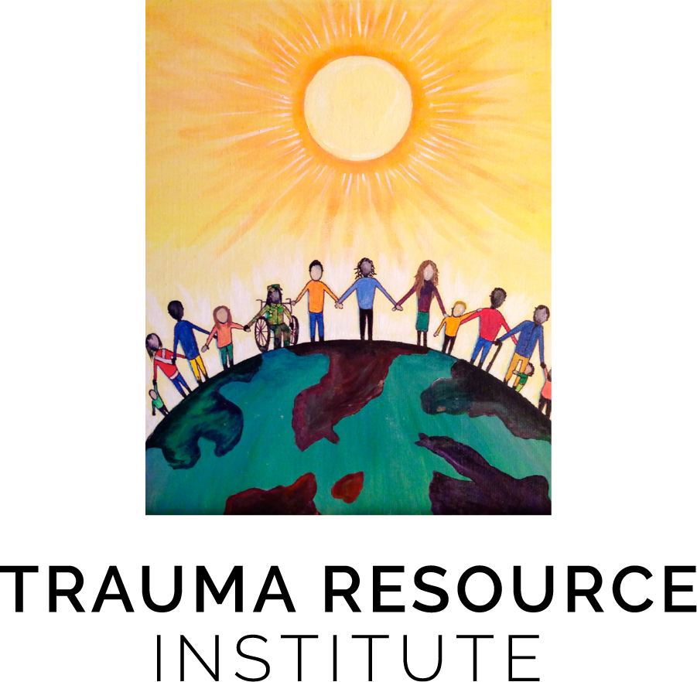

VIRTUAL TRAINING

EMDR Basic Training and/or

Trauma Resilience Model (TRM)® Training

Two specialized certificate programs are offered that provide advanced psychotherapy skills for working with those with complex trauma and dissociation. TRM is based on the biology of resilience and helps one learn how to restore balance to the body and the mind after traumatic experiences. TRM is research-informed and was named a promising practice by the Department of Defense. Somatic work combined with EMDR Therapy are powerful tools that can be integrated into any therapist’s practice. EMDR Therapy is an evidence-based psychotherapy for trauma. These trainings are offered by recognized experts in trauma treatment. Separate certificates of completion for Basic Training in EMDR from EMDRIA for those who complete Part 1 & 2 of EMDR and for those who complete Part 1 & 2 of TRM from from the Trauma Resource Institute will be awarded. For those who complete all 4 trainings, participants will receive a Certificate in Integrative Trauma Psychotherapy from Fairfield University
Basic Training in EMDR Therapy Part 1 & 2 Trauma Resilience Model Levels 1 & 2
Part 1: April 10-12, 2021 See dates and register at the link below for:
Part 2: August 6-8, 2021 TRM Level 1 & 2 Trainings https://www.traumaresourceinstitute.com/trm-trainings
Cost:
EMDR Part 1: $750 ($650 for students) TRM Level 1: $750 ($650 for students*)
EMDR Part 2: $750 ($650 for students) TRM Level 2: $750 ($650 for students*)

“Early Bird” pricing: Receive $50 dollars off of each training for registering at least one (1) month prior to the training. *Students must contact Claire Bridge at 909-294-9434 for student discount code prior to registering for TRM Level 1 and TRM Level 2.

A half-day refresher (mornings only) EMDR training without practica is offered at half price, $315, for those already EMDR trained.

CEs:
- 40 CEs awarded for the EMDR training. This program has been approved for Continuing Education Credit Hours by the National Association of Social Workers, CT and meets the continuing education criteria for CT Social Work Licensure renewal. Approval also meets the continuing education criteria for CT LMFTs, LPCs, and licensed psychologists. These contact hours are accepted by the ANCC for recertification for PMHNPs.
- 18.5 CEs are offered for each TRM training by The Trauma Resource Institute for an additional $40 per training. Please Click Here for more information.
Students in a licensed mental health provider program are eligible for all trainings. A CV and a letter from the Director of their program stating that you are a student in good standing and have permission to participate in these trainings should be sent to cheryl@platinumken.com for the EMDR Training.
Faculty
Elaine Miller Karas LCSW is the Executive Director and co-founder of the Trauma Resource Institute and adjunct faculty at Loma Linda University’s School of Social Work and Social Ecology. She is the author Building Resilience to Trauma: The Trauma and Community Resiliency Models. Elaine is the co-founder and co-developer of the Trauma Resiliency Model and has taught this model and the Community Resiliency Model in Haiti, China, Mexico, Kenya, Nepal, Germany, South Africa, Guatemala, Northern Ireland, Iceland, Tanzania, Rwanda, Turkey and the Philippines.
Kate Wheeler PhD, PMHNP-BC, APRN, FAAN is a professor of nursing at the Fairfield University Egan School of Nursing and the director of the psychiatric nurse practitioner program. Kate specializes in trauma in her private practice and is an EMDR International Association (EMDRIA) Approved Consultant and Trainer. She is a psychoanalyst and has been EMDR certified since 2001. She is a past president of the EMDRIA. Kate has served as a consultant on numerous EMDR research projects in the past 10 years and has published a number of research studies on EMDR with other colleagues. She is on the editorial boards of the Journal of EMDR Practice and Research and the Journal of the American Psychiatric Nurses Association. Kate wrote the award-winning textbook Psychotherapy for the Advanced Practice Psychiatric Nurse.

For more information, please email:
Kate Wheeler APRN, FAAN
kwheeler@fairfield.edu
or
Cheryll Kenn, LCSW
cheryl@platinumken.com

REGISTER HERE FOR EMDR TRAINING: https://www.cherylkenn.com/emdr-training/

REGISTER HERE FOR TRM TRAINING: https://www.traumaresourceinstitute.com/trm-trainings

